* Keyed-in means generally we write the sql query in this process
* Logical query processing means sql server process the query in this order

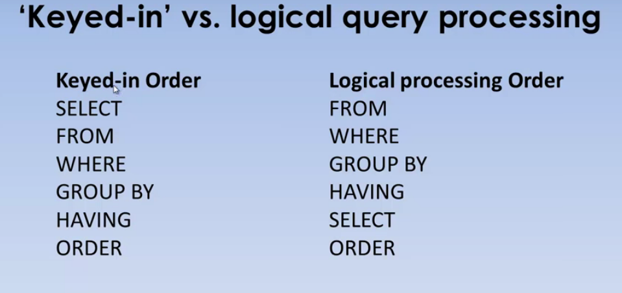

Logical query processing example

